#### Macintosh HD:Users:hirschn:Google Drive:fishmercuryicon.JPGRadish Seed Dose Response Worksheet – Student Version

**Experiment 1**: Radish Seed Dose Response

**My Name**________________________________

**Date**____________________________________

**My Chemical Mixture**_____________________________

*Why did you choose this chemical mixture?*

**My Calculations:**

**Using dilutions to make all three dilutions (50%, 25%, 12.5%)**

*Hint* – make 40ml of your 50% chemical mixture (See Figure 1)

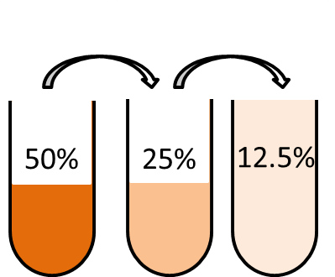

**Figure 1**. Since we are going down by half each time, we can use dilutions to create all three chemical mixtures.

1. **Make a 50% chemical mixture**

How many ml of chemical mixture do I need to make a 50% solution? How many ml of water?

*Example*: If Mary has 50ml of water, plus 50ml of vinegar and she mixes them together, she has a 50% mixture, because it is half water and half vinegar.

*Calculations for the 50% chemical mixture*

1. **Make a 25% chemical mixture**

*Hint* – 25% is half of 50% (2 quarters = 50 cents)

*Hint* – make 40ml of your 25% chemical mixture

*Example*: If Mary took 50ml (one-half) from her water-vinegar solution (25ml vinegar, 25ml water), and added 50ml of more water, what would she have now?

_____ml vinegar

_____ml water

What is the percentage of vinegar in her solution now?

*Calculations for the 25% chemical mixture*

1. **Make a 12.5% chemical mixture**

*Hint*: 12.5% is half of 25%

*Hint*: You only need 20ml, but you will end up with 40ml

*Example*: If Mary took 50ml (one-half) from her new water-vinegar solution and added 50 ml of more water, what would she have now?

______ml vinegar

______ml water

What is the percentage of vinegar in her solution now?

*Calculations for the 12.5% chemical mixture*