

What Makes a Product Hazardous?
Activity Credit: HYDROVILLE CURRICULUM PROJECT ©2004, Oregon State University, http://www.hydroville.org

It is estimated that the average house contains 3 to10 gallons of hazardous products. Many of the products we use for housework, gardening, home improvement, or car maintenance contain potentially hazardous substances. When used or disposed of improperly, these products can become personal health and safety concerns and can also cause problems in the environment. Therefore, it is important to understand what makes a product hazardous, how to identify hazardous substances, and learn how to use and handle these products safely.

Hazardous Substances
A hazardous substance is defined in federal government regulations as “one that may cause substantial personal injury or illness during reasonable handling or use, including possible ingestion by children.” According to the Federal Hazardous Substances Act (FHSA), household products are hazardous if they contain substances that have one or more of the following hazardous properties:
Corrosive: A product that can burn or destroy living tissue, such as skin or eyes or by chemical action. Examples: Drain cleaners, oven cleaners, and lye.
Irritant: A product is an irritant if it is not corrosive and causes injury to the area of the body that it comes in contact with after immediate, prolonged, or repeated contact.
Examples: Toilet cleaners, chlorine bleach cleaners, and some pool chemicals.
Strong Sensitizer: A product that can cause an allergic reaction upon repeated uses of the same substance. Usually this does not happen when a person first comes in contact with the product, but after a second exposure.
Examples: Dyes, oils, tars, rubber, soaps, cosmetics, perfume, insecticides, wood resins, plants, paints, plastics, glues, fiberglass, metals, and polishes.
Flammable: Any substance, liquid, solid, or the contents of a self-pressurized container, like aerosol cans, that can be easily set on fire or ignited. Extremely flammable, flammable, and combustible are the three types of flammability based on testing.
Examples: Paint thinners, some solvents, adhesives, rubber cement, and hair spray.
Toxic: In addition, a product is toxic if it can cause long-term effects like cancer, birth defects, or neurotoxicity (toxic to nerves).
Examples: Brake fluids, fungicides, insecticides, fertilizers, rat poison, and antifreeze.

Routes of Exposure
A product is hazardous if it can produce personal injury or illness to humans when inhaled, swallowed (ingested), or absorbed through the skin.
- Ingestion – eating or drinking hazardous substances or contaminated foods and water and absorbing these substances through your gastrointestinal tract.
- Inhalation – breathing in gases, vapors, and sprays that are absorbed through the lungs and enter the bloodstream.
- Dermal (skin or eye contact) – some hazardous products can be absorbed through the skin or your eyes and cause injuries. How Do You Know if a Product is Hazardous?
The FSHA requires that if a product contains a hazardous substance, the product must bear a label of specific size, and the label must contain certain information, depending on the toxicity of the product. “Signal Words” are found on every hazardous product label and show how toxic or hazardous a product can be. If there is no signal word on a product it is not hazardous.

Table 1. FSHA Signal Words for Household Products
 | Signal Words | Properties | Examples
 | POISON | highly toxic | varnish remover, antifreeze
 | DANGER | extremely flammable, corrosive, or highly toxic | bleach, WD-40
 | WARNING  CAUTION | for all other hazardous products | carpet cleaner,  cleanser

Other Hazardous Household Products - Pesticides
Pesticides are defined as chemicals used to prevent, destroy, or repel pests: insect, mice, weeds, fungi, and bacteria. Pesticides also include household products, such as disinfectants or cleaners that are used to destroy the growth of harmful bacteria, viruses, or fungi on household surfaces. The Environmental Protection Agency (EPA) registers and regulates pesticides under the Federal Insecticide, Fungicide and Rodenticide Act (FIFRA). These products must meet the basic standards: (1) the product will not cause harmful effects to human health or the environment and (2) that product labeling must meet FIFRA requirements. Examples: insecticides, rodenticides, herbicides, fungicides, etc.

Pesticides also have signal words, but they are based on the degree of toxicity or how poisonous the product is. Tests are conducted to determine the Lethal Dose50 (LD50) of each pesticide. Lethal Dose50 is when 50% of the test population, which is usually mice or rats, dies when administered a specific dose of a pesticide. The oral LD50 of a substance is expressed in milligrams of chemical per kilogram of body weight (mg/kg). Table 2 indicates how signal words are determined for use on pesticide labels.

Table 2. FIFRA Signal Words and Toxicity Rating Scale
 | Signal Words | Toxicity | Oral LD50 (mg/kg) | Examples
 | DANGER-POISON | highly toxic | 0 - 50 | indoor/outdoor insect killer
 | DANGER | highly toxic/corrosive | 0 - 50 | toilet bowl cleaner
 | WARNING | moderately toxic | 50 - 500 | flea spray
 | CAUTION | slightly toxic | 500 - 5,000 | rat poison

Read Before You Use!
Besides signal words, product labels contain other important information, such as instructions for safe handling, use, and storage; active ingredients; and first aid safety. As a consumer, make it a habit to read all label information before using any product.
Student Worksheet: Name_______________________________

Reading Hazardous Household Product Labels
There is a lot of information on product labels, but this activity focuses on identifying hazardous household products.

Procedure:
- Read ten product labels for the various household products on display. Find the Hazardous Properties, Signal Words, and Route of Exposure for each product.
- Refer to Student Handout 1: What Makes a Product Hazardous? to help you complete the table below.

SAFETY: Be sure that ALL products are handled safely. DO NOT open any products.
Product | Hazardous Properties -  List properties that make it hazardous. | Signal Word | Route of Exposure  (Ingestion, Inhalation,  Dermal – skin or eye contact)

Conclusion Questions:

- Which hazardous properties were most common?

- Which signal word was most common?

- Which products are most toxic? How did you determine this?

- What are the three routes of exposure? Which route was most common?

- What product(s) determine the signal words based on toxicity testing?

- What did you learn from this activity?

Pesticide Labels for Mold Control:

LYSOL® DISINFECTANT – Antibacterial Kitchen Cleaner

FRONT LABEL
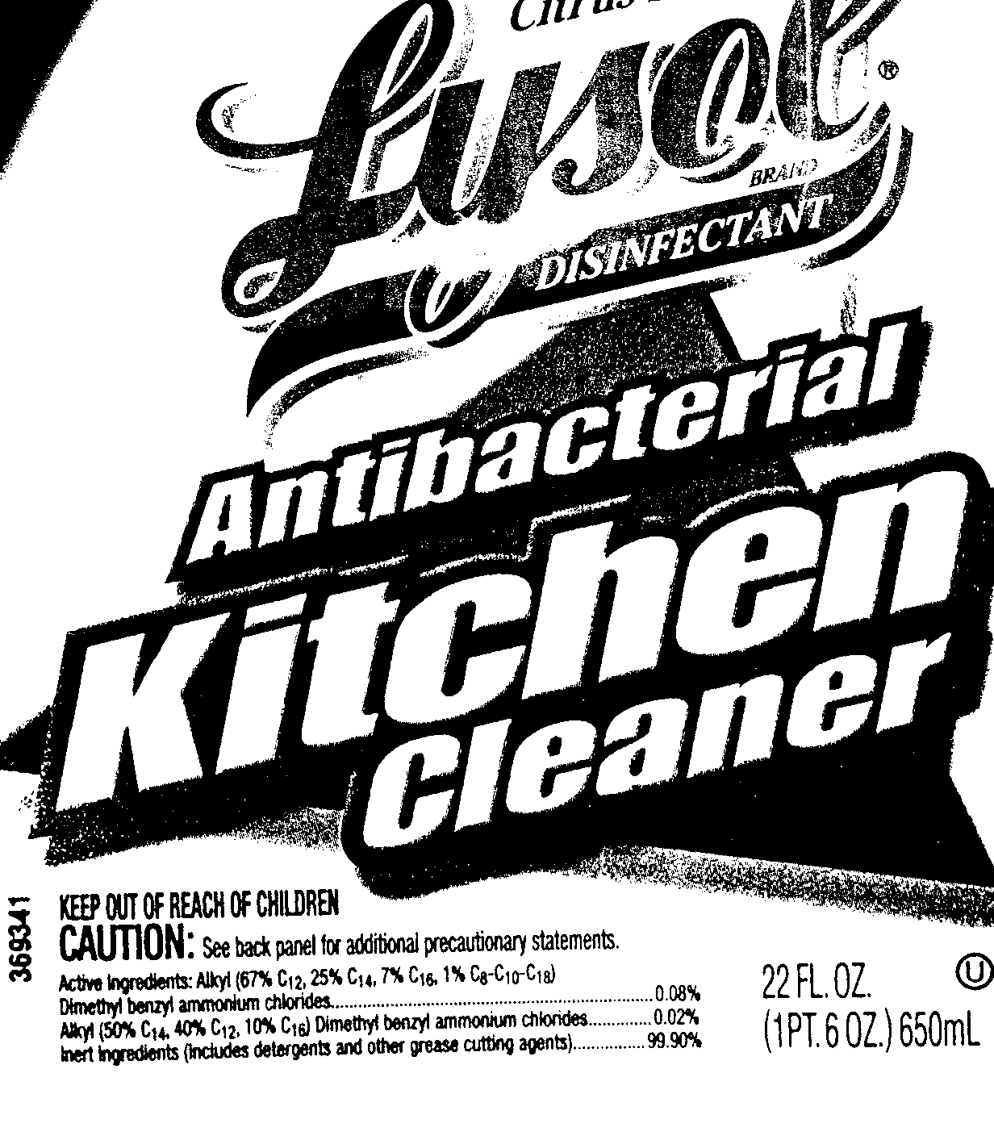
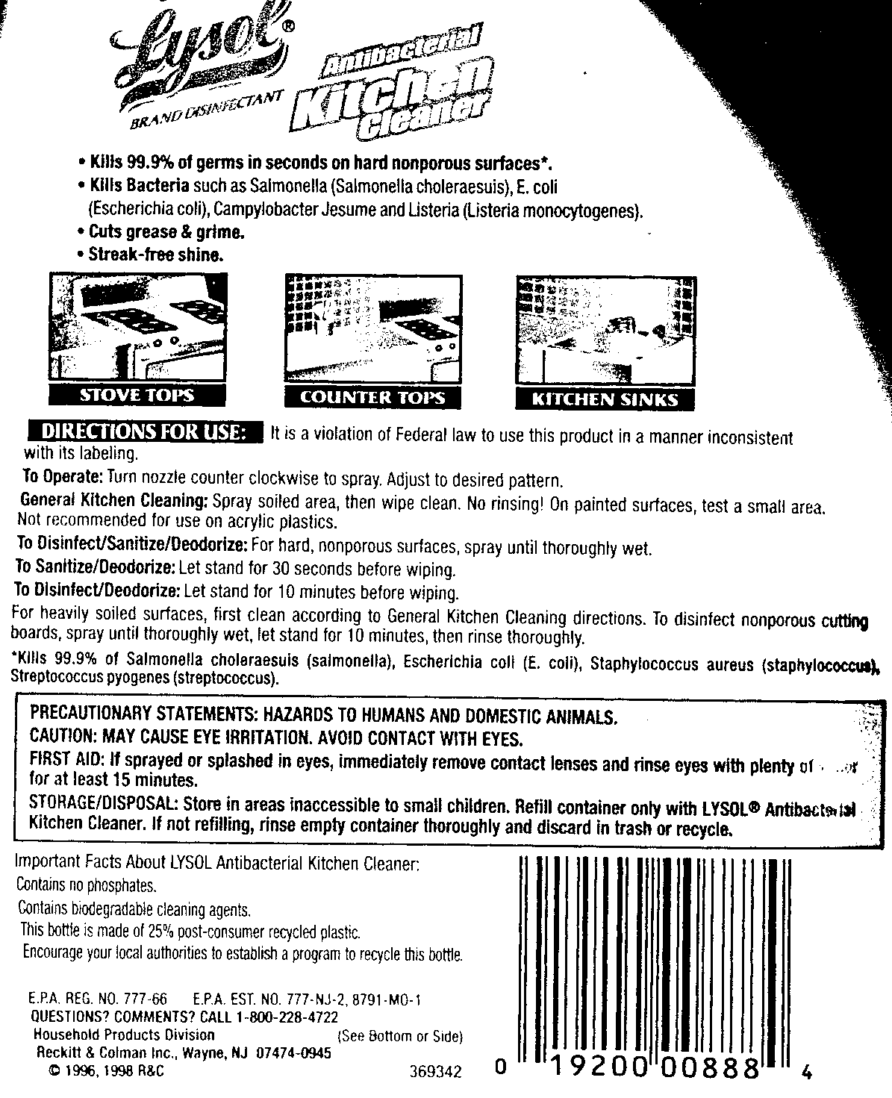
BACK LABEL

Pesticide Labels for Mold Control:

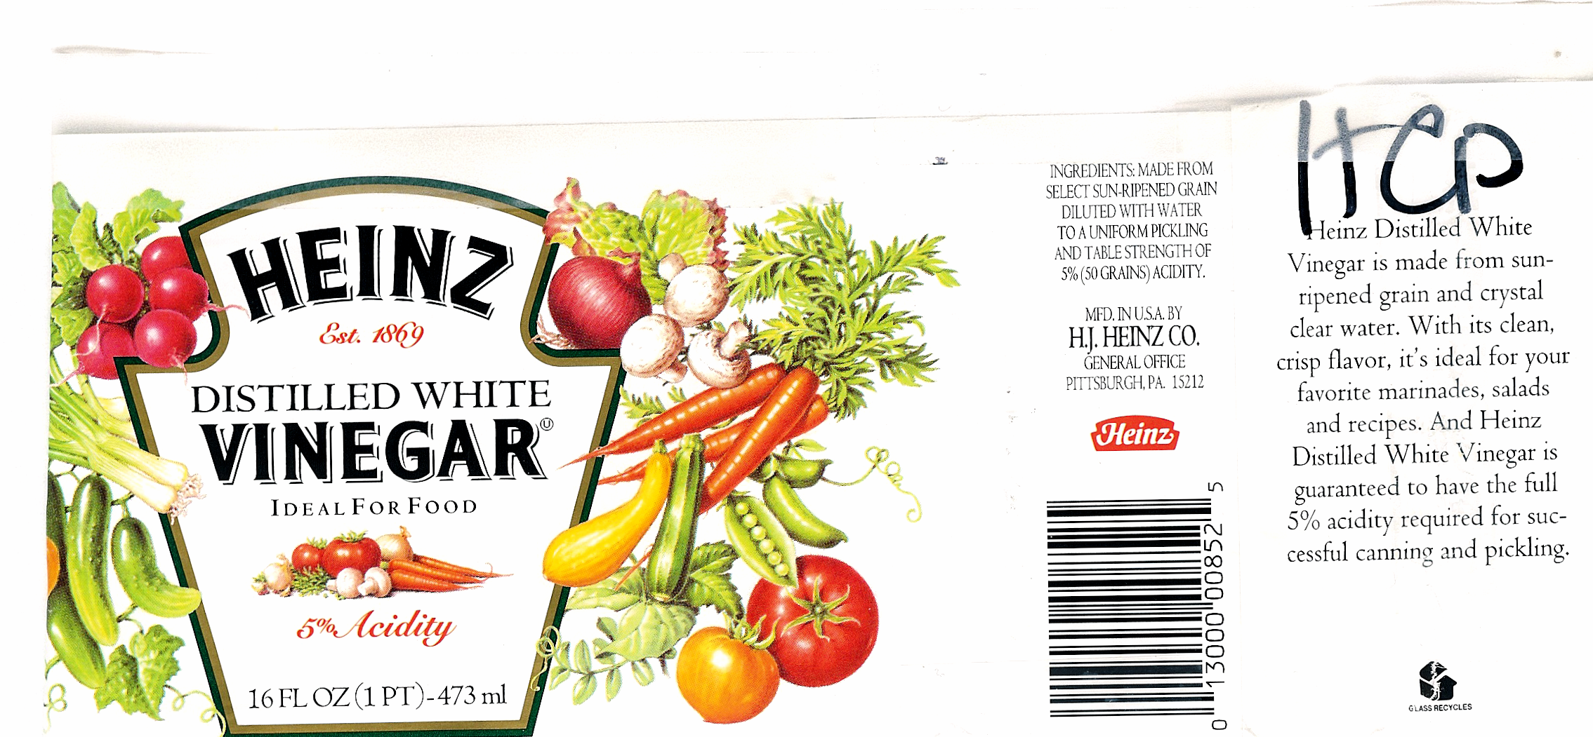
HEINZ® - Vinegar
INGREDIENTS:
Made from select sun-ripened grain diluted with water to a uniform pickling and table strength of 5%
(50 grains) acidity.

Heinz Distilled White Vinegar is made from sun-ripened grain and crystal clear water. With its clean, crisp flavor, it’s ideal for your favorite marinades, salads and recipes. And Heinz Distilled White Vinegar is guaranteed to have the full 5% activity required for successful canning and pickling.
Pesticide Labels for Mold Control:
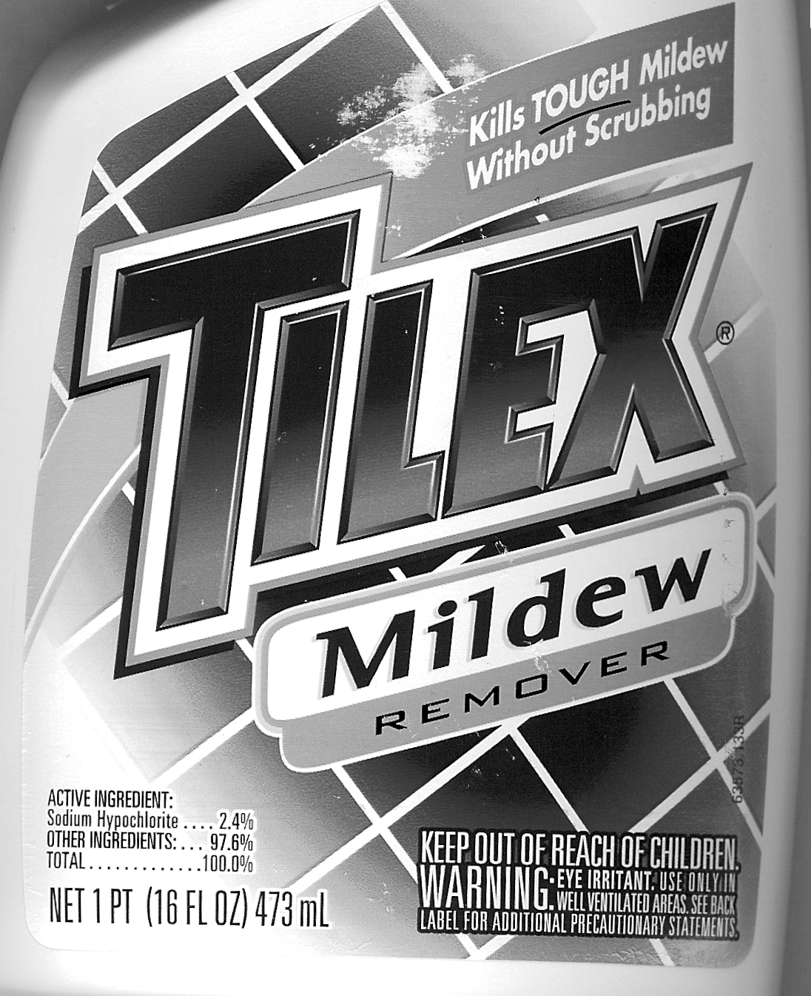
TILEX® – Mildew Remover

FRONT LABEL

BACK LABEL

